**Maheshavel L**

**17C048**

**Exercise 1**

**Created Bucket and uploaded file:**

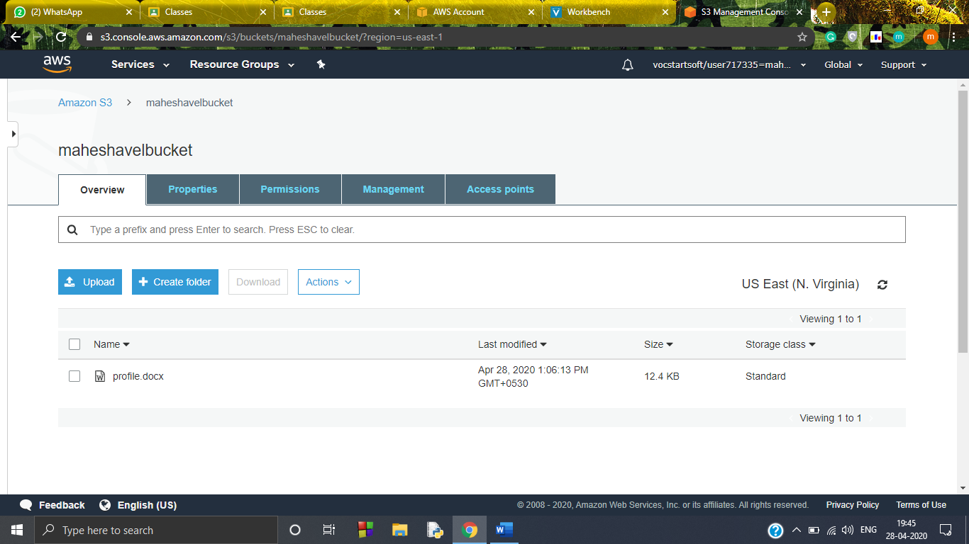

**Object url:**

[**https://maheshavelbucket.s3.amazonaws.com/profile.docx**](https://maheshavelbucket.s3.amazonaws.com/profile.docx)

**Private access:**

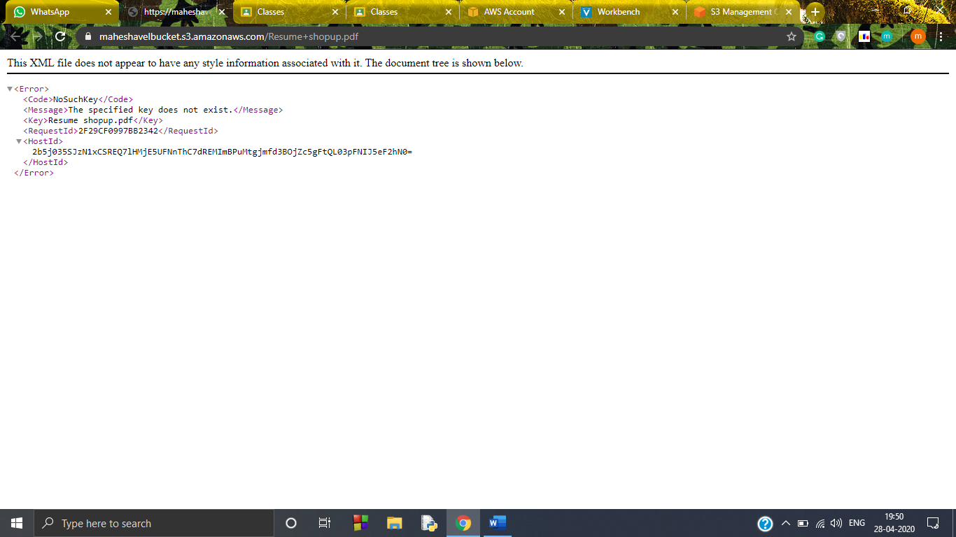

**Public access:**

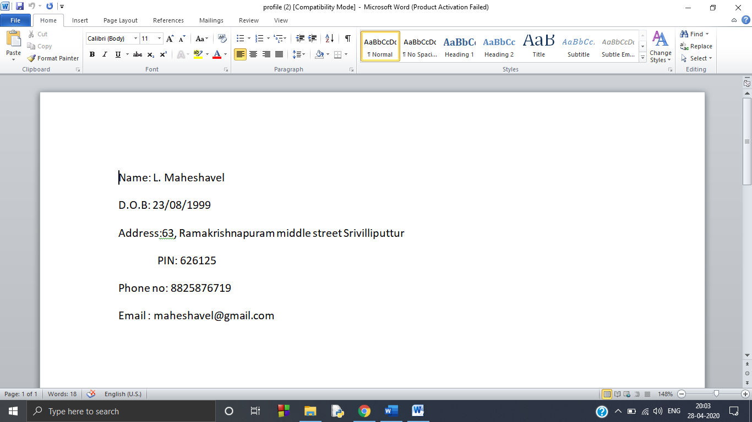

**Could download and view the file**